# Hospital Multi-Parameter Patient Monitoring Application

**Team Name:** Java First

**Team Advisor:** Na, Hyuntae

**Team Members:**

Alphonso McKenzie

Phone: 301-741-8086

Email: [ajm6684@psu.edu](mailto:ajm6684@psu.edu)

Role: Project Manager, Development Team Member, QA Engineer

Sean Todd

Phone: 717–717-0395

Email: [seantodd114@gmail.com](mailto:seantodd114@gmail.com)

Role: Development Team Member, QA Engineer

Charles Todd

Phone: 717–717-0396

Email: [11ctodd@gmail.com](mailto:11ctodd@gmail.com)

Role: Development Team Member, QA Engineer

Logan Kollar

Phone: 717-283-9889

Email: [lrk5177@gmail.com](mailto:lrk5177@gmail.com)

Role: UI/UX designer, Development Team Member

**GitHub Repository:** https://github.com/Alphonso74/Patient-Monitory-Application-

**Patient Monitoring Application**

* **Patient** 
  + Each patient has information and data connected to them that is updated constantly whether it’s by a doctor, nurse, or their vital conditions that is monitored by a medical machine.
    - In reality this application would be connected to a medical machine, and that machine would be hooked up to the patient in order to track status conditions such as heartbeat rate.
  + Data monitored
    - Electrocardiograph (ECG)
    - Respiration
    - Invasive and Non-Invasive blood pressure
    - Oxygen Saturation in human blood (SP02)
    - Body temperature
    - Heartbeat rate
    - Temperature
    - Pain level
    - Sleep pattern
    - Diet
    - Voiding pattern (urinating-peeing and defecating-pooping)
    - Other data
      * Shortness of Breath
      * Nausea
      * Vomiting
      * Fatigue
  + Some data is subjective, meaning the patient will have to specify the state of a given field to the doctor in order for it to be updated to their status….for instance, pain level, and level of fatigue. Others will just be monitored directly by nurses and not automated by medical machines such as sleep pattern, voiding pattern, and nausea.
  + Each patient is marked with a Triade tag by a first responder or medical personnel upon admission into the hospital. This will determine the type of alerts that are sent through notifications or windows on the feed.
    - Black (Expectant) - Pain medication only, until death
    - Red (Immediate) - Life-threatening injuries
    - Yellow (Delayed) - Non-life-threatening injuries
    - Green (Minimal) - Minor injuries
* **Doctors** 
  + Doctors view of the feed may be different depending on the type of data they would want to be monitoring.
  + Has the ability to update certain patient data that isn’t monitored by medical machine and such as sleep pattern, voiding pattern, nausea amount, pain level, and level of fatigue.
* **Nurses** 
  + May have basic or advanced view of patient’s status details
  + Has the ability to update certain patient data that isn’t monitored by medical machine and such as sleep pattern, voiding pattern, nausea amount, pain level, and level of fatigue.
* **Receptionists** 
  + Ability to enter patient data into database
    - Once patient information is admitted then the patient will show on the live feed.
* **News Feed very rough idea**
  + Users are able to click on patients Icons of status details in order to see more details about the patient, or more details about a specific status field for that patient
  + Nurses and doctors are able to modify certain data that isn’t automatically tracked by medical machine patient is hooked up to
  + If a patients’ status gets critical, for instance if their heartbeat rate gets too high or too low, all users of the application signed into an account for that specified hospital will be notified with an alert with corresponding details and instructions. The corresponding patient’s icon on the feed changes automatically when this happens to be bright red, and certain significant information prominent to the condition are displayed upfront to that user’s data field on the feed.

Vertical Display newsfeed draft

Horizontal Display newsfeed draft

* **Patient Profile (Patient information outside of feed): Example (Google)**

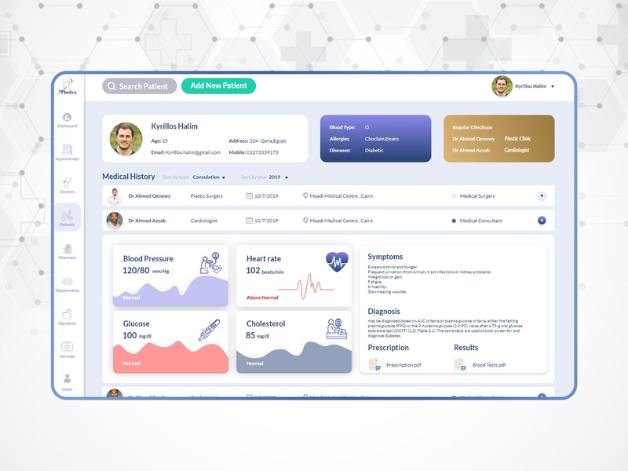

* **Direct messaging feature**
  + Doctors, Nurses, and receptionists will have the ability to direct message one another directly in this app with their account
    - This feature would be great when a doctor is on the opposite side of the hospital from a patient and needs to communicate with a nurse on the other side.